NAME: Ahmed Abdel-Latif Mohamed Mohamed

B.N: 89

DATE:

TOPIC: BIG DATA

GITHUB LINK :

GITHUB PAGE (published-website) :

APPLICATION PRIEF:

Data sets grow rapidly, to a certain extent because they are increasingly gathered by cheap and numerous information-sensing Internet of things devices such as mobile devices, aerial (remote sensing), software logs, cameras, microphones, radio-frequency identification (RFID) readers and wireless sensor networks.The world's technological per-capita capacity to store information has roughly doubled every 40 months since the 1980s; as of 2012, every day 2.5 exabytes (2.5×260 bytes) of data are generated. Based on an IDC report prediction, the global data volume was predicted to grow exponentially from 4.4 zettabytes to 44 zettabytes between 2013 and 2020. By 2025, IDC predicts there will be 163 zettabytes of data. One question for large enterprises is determining who should own big-data initiatives that affect the entire organization.

Relational database management systems, desktop statistics[clarification needed] and software packages used to visualize data often have difficulty handling big data. The work may require "massively parallel software running on tens, hundreds, or even thousands of servers". What qualifies as being "big data" varies depending on the capabilities of the users and their tools, and expanding capabilities make big data a moving target. "For some organizations, facing hundreds of gigabytes of data for the first time may trigger a need to reconsider data management options. For others, it may take tens or hundreds of terabytes before data size becomes a significant consideration.

SCREEN SHOTS:

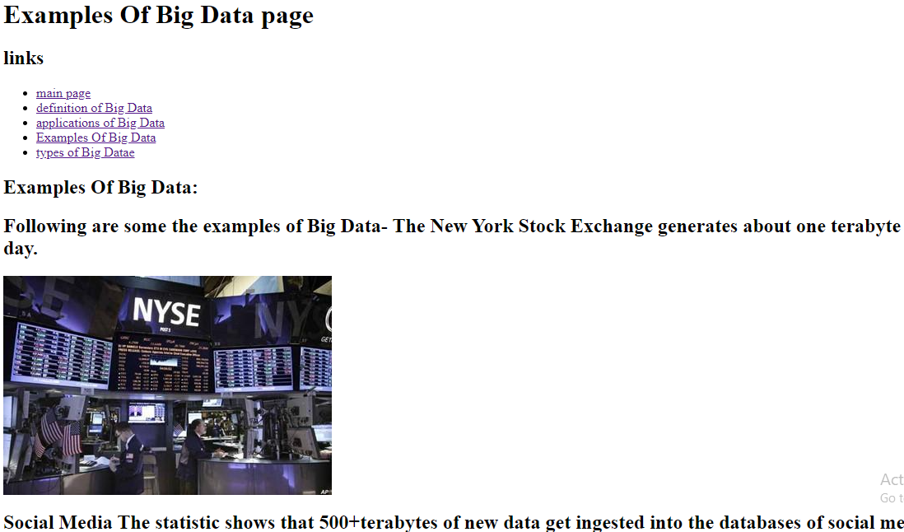

SOURCE CODE:

